Task Document

Please follow the instruction tasks below to the best of your ability. You may ask for help at any time and can skip tasks. If you do skip tasks please note you have done so and the reason why.

1. Try to find the cheapest hospital in New York with the procedure “039” or 'EXTRACRANIAL PROCEDURES W/O CC/MCC', enter the hospitals name below
2. Turn on your geolocation, explain how you did this
3. How many hospitals are in the zip code “12208” with the procedure name “039” or 'EXTRACRANIAL PROCEDURES W/O CC/MCC' , the names below
4. What is the closest hospital to the address “14 West Broadway, Boston” with the procedure “039” or 'EXTRACRANIAL PROCEDURES W/O CC/MCC', enter the hospital name below
5. Find a hospital that has the procedure “039” or 'EXTRACRANIAL PROCEDURES W/O CC/MCC' that costs between 8200 and 8400 in New York state, enter the hospital name below

Once you are finished please fill in the questions on the back of this sheet

Tester Number: _____

Please fill the squares with Xs until you have reached the point of your answer

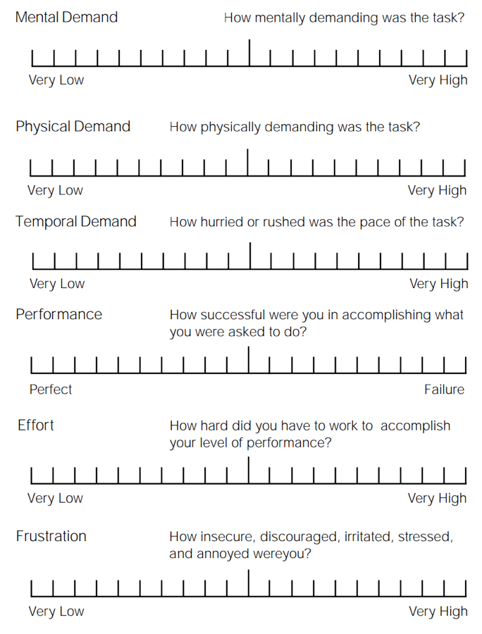

Tester Number: _____